What is Science?
Day 3: Lesson Quiz
Choose the letter of the best answer.

1. What is the term for the cumulative body of observations on which scientific explanations are based?
A. peer review
B. pseudoscience
C. logical reasoning
D. empirical evidence
2. Below is a drawing of the astrological zodiac signs.
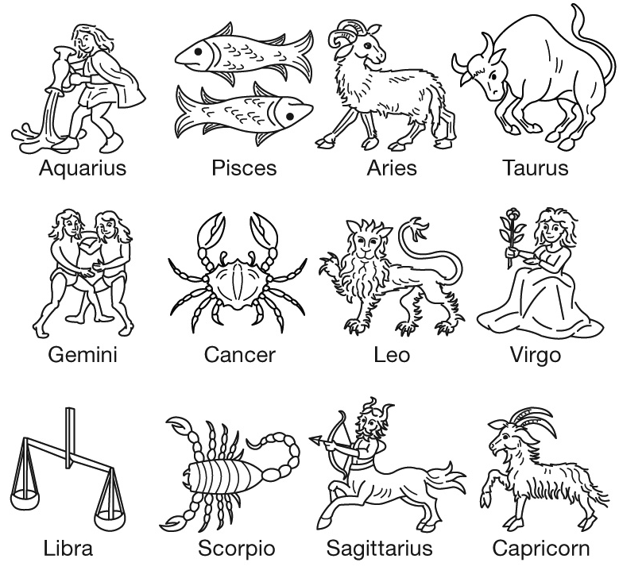
Astrology is an example of a pseudoscience. Why is astrology considered a pseudoscience, unlike astronomy, which is a science?
A. because astrology is older than astronomy
B. because it is not based on empirical evidence
C. because it is based on the scientific method
D. because it can be easily replicated by other scientists
3. Which title should be classified as pseudoscience?
A. Is Life Possible on Mars?
B. How Aliens Built the Pyramids
C. A Quantifiable Study of Emotional Intelligence
D. The Disappearance of Ancient Civilizations in South America
4. Why is objectivity important to scientific investigations?
A. Objectivity means that the opinions of the scientist do not affect the results.
B. Objectivity means that the opinions of the scientist are included in the results.
C. Objectivity means that scientists repeat investigations; this makes the results more valid.
D. Objectivity means that scientists add their own biases and beliefs to their data, which is important to obtaining valid conclusions.
5. Two students want to investigate how different substances can exist as solids, liquids, or gases. They each develop a similar question that they intend to answer. Their experiments include different steps, which leads to the students having slightly different results. Which of the following statements about their investigations is most correct?
A. Because they had different results, neither investigation can be considered valid.
B. Because they had different results, only one student’s investigation will be valid.
C. Scientific investigations can often have different steps; it is still possible for each student to have valid results.
D. Scientific investigations should always follow the same steps; the students should re-do their investigations with the same steps.

